21 February 2023
Experiential Learning Multimedia dept.
Multimedia Club of HMV organizes Seminar on Video Broadcasting
The PG Department of Multimedia organized a Seminar on Video Broadcasting under the able guidance of Principal Prof Dr. (Mrs.) Ajay Sareen. The session was lead by Er. GarimaBawa, Senior Enterprise Engineer from Evertz Microsystems, Canada. Dean Academics Dr. SeemaMarwaha welcomed the Resource Person and said that the main purpose behind such seminar is to provide a platform where the professionals from the industry and the students can directly communicate with each other and students can enhance their knowledge about the latest trends and technologies prevailing in the industry. Er. GarimaBawa, highlighted how the news channel broadcast their live news and motivated the young minds to utilize these techniques for their knowledge enhancement. She demonstrated the live example of Video Broadcasting being used in Canada. She developed a simple graphic appearance of a news channel CNBC TV18 in 10 minutes live in the session. The Resource Person fuelled the students with more enthusiasm to create and demonstrate real life examples during their project course work. This session makes the student aware about the recent changes happening in the Digital world from the point of view of a Multimedia and Video Broadcasting Professional. In an interactive session with students, she guided the students about different start-ups and guided them to follow their dreams with the help of the recent digital resource. At the end of the session, Student queries were taken up by the Resource Person
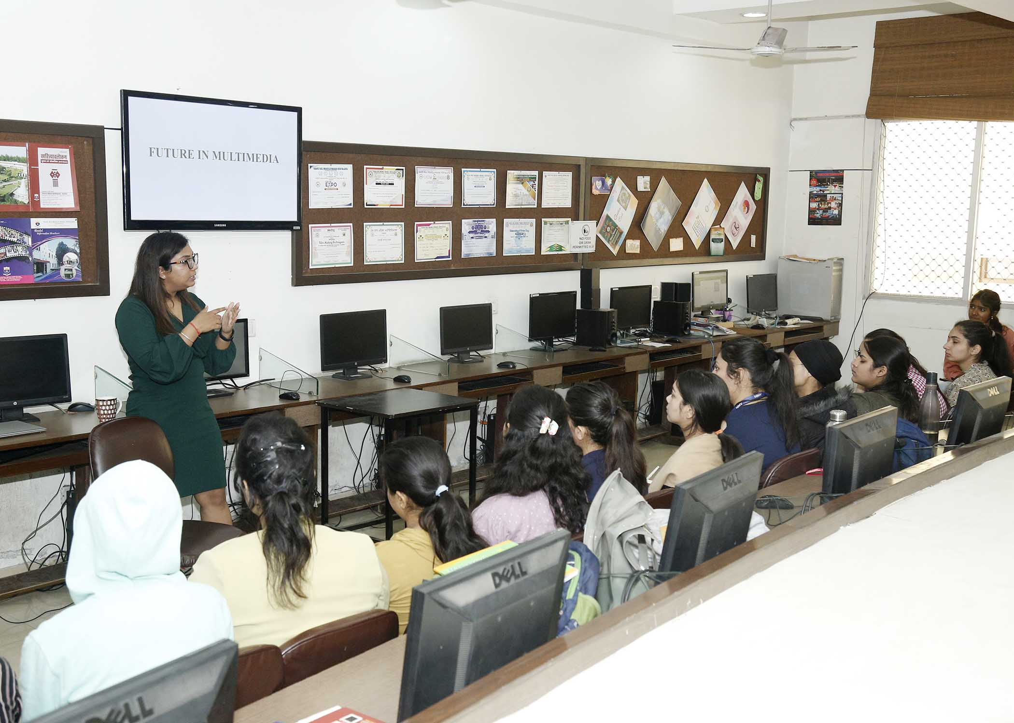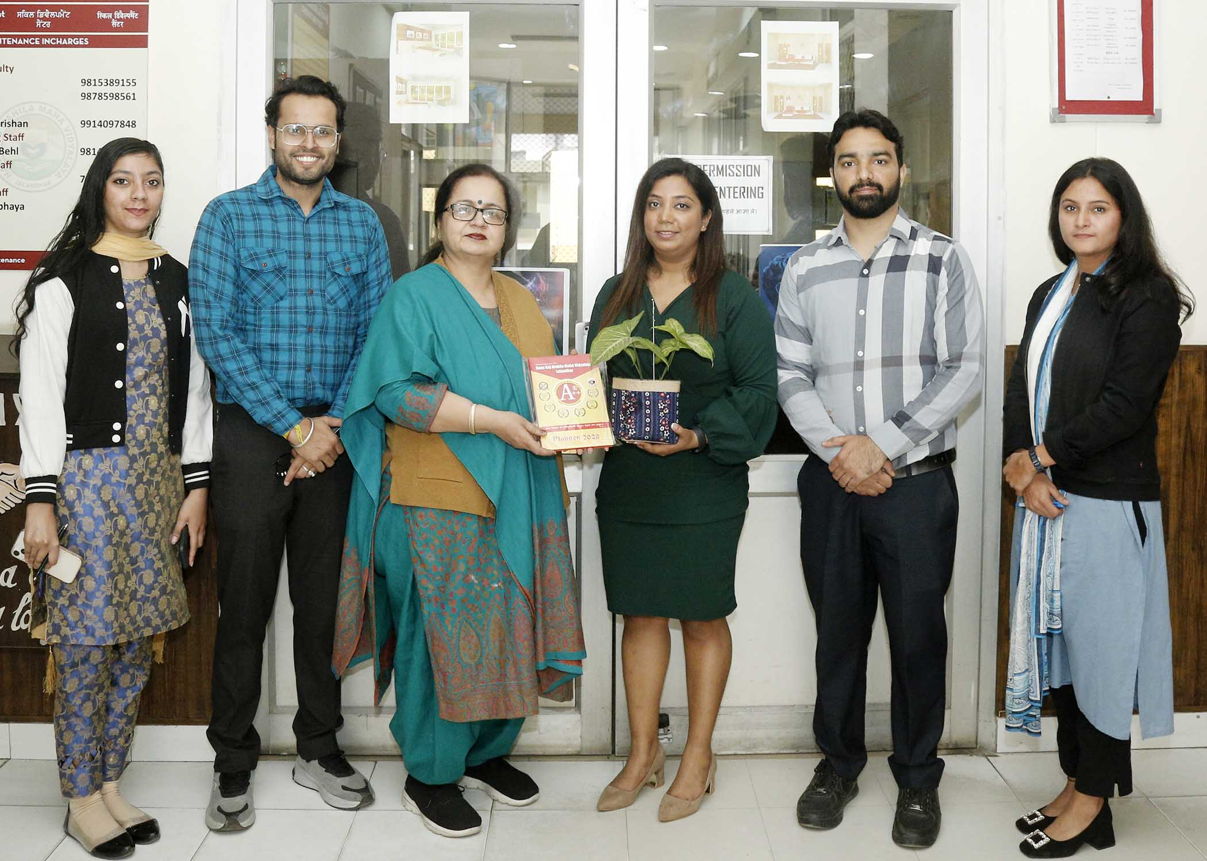
10 February 2023
Multimedia Club of PG Department of Multimedia, HMV organized a visit to Machinex – 2023
The Multimedia Club of PG Department of Multimedia organized a visit to Machinex – 2023 for the students of B. Design (Multimedia), B. Vocational & M. Vocational (Web Tech. & Multimedia). The students had an opportunity to know about the cloud storage and working infrastructure. Mr. Mukesh Bansal, Director, Btrack India Pvt. Ltd. guided the students about their solutions for Cloud hosting , Backup and Security Services to their esteemed clients. He also provided knowledge about their technical support to websites and softwares through their VPS and different Servers. During the visit, the students came to know about the impression and laser printing on Pens, Book Covers and Metal via the industry BEE Prints. The students got awareness of leading technologies used in the industries that will help them in increasing their knowledge for better employment opportunity. Mr. Ashish Chadha, Head companied the students to the exhibition. Principal, Prof. Dr. (Mrs.) Ajay Sareen praised the efforts of the department. On this occasion Mr. RishabhDhir were also present.
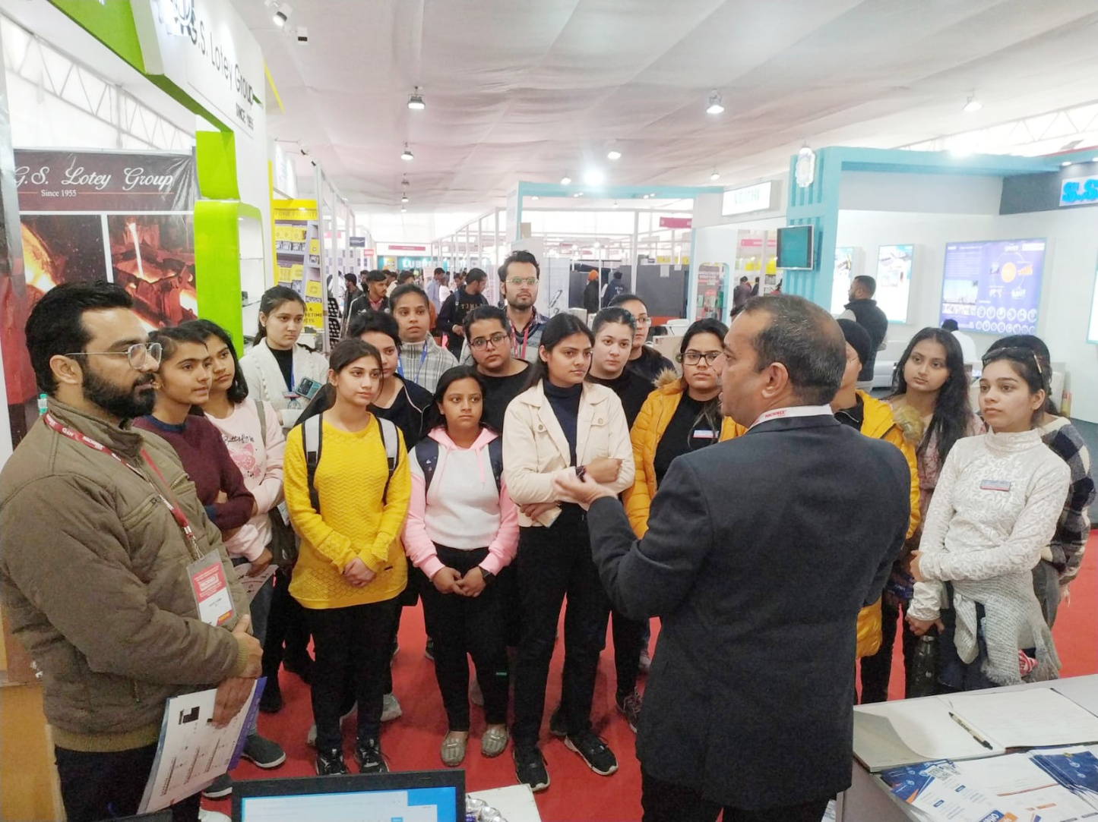

21 November 2022
Participative Learning
Live Drawing Session for First Year Students
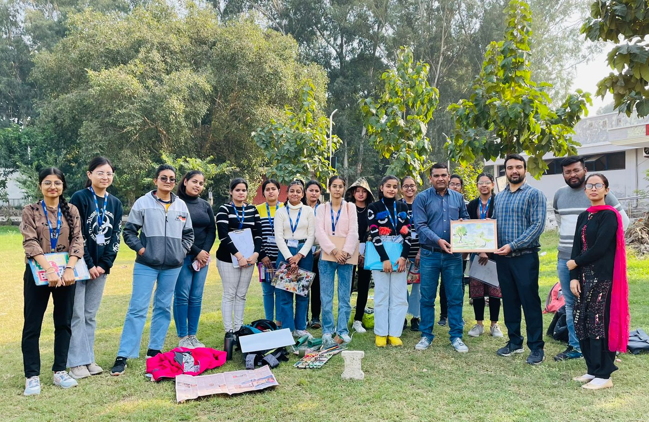
The PG department of Multimedia in collaboration with department of Fine Arts organized Live Drawing Session for the first year students of B. Design (Multimedia). The students had an opportunity to know about the basic knowledge of live drawing techniques applied during sessions. The students were instructed by Dr. Shailendra and Nishita of Fine Arts Department. Students developed beautiful sceneries around the campus. Mr. Ashish Chadha, Head, PG Department of Multimedia acted as coordinator of this session.

21 October 2022
Diwali Exhibition - 2022
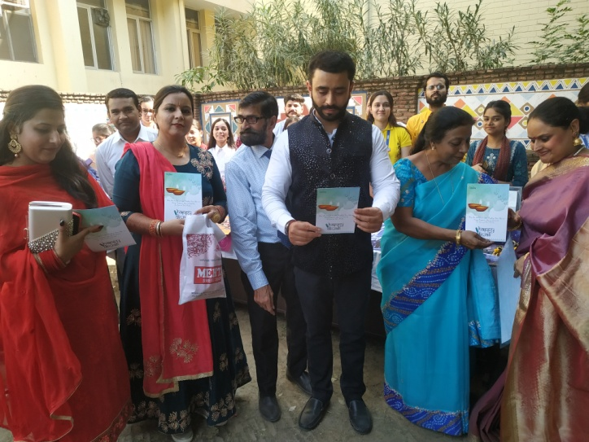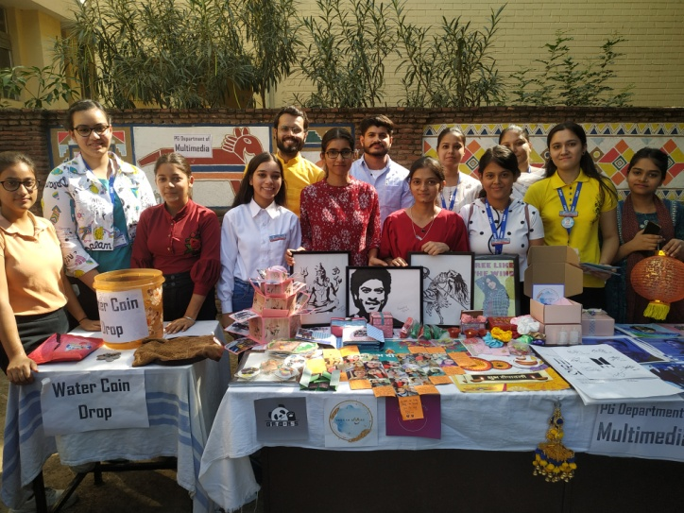
The PG Department of Multimedia of Hans Raj MahilaMahaVidyalaya, Jalandhar organized Exhibition Cum sale of Graphic Designing on “Jashan-E-Diwali” under the able guidance of Principal Prof. Dr. (Mrs.) Ajay Sareen. The students exhibited their creativity and displayed designer posters, Stickers and different decorative items etc The Chief Guest of the occasion was Advocate Vikrant Rana, State Joint Secretary, Legal Wing, AamAadmi Party, Punjab. He appreciated the art work and said that such exhibitions encourage the students for exhibiting their skills and making them independent. Such endeavours make them realize their own culture and traditions. The Department also had a stall of innovative game like wavy coin which was thoroughly loved and enjoyed by the chief guest and other delegates. Principal Prof. Dr. (Mrs.) Ajay Sareen congratulated the organizing team and said that such exhibitions enhance the creativity of the students. She also gave best wishes on the occasion of Diwali. Mr. Ashish Chadha, Head and Mr. RishabhDhir were also present. All the staff members and students enjoyed the exhibition.

5G Launchby Prime Minister
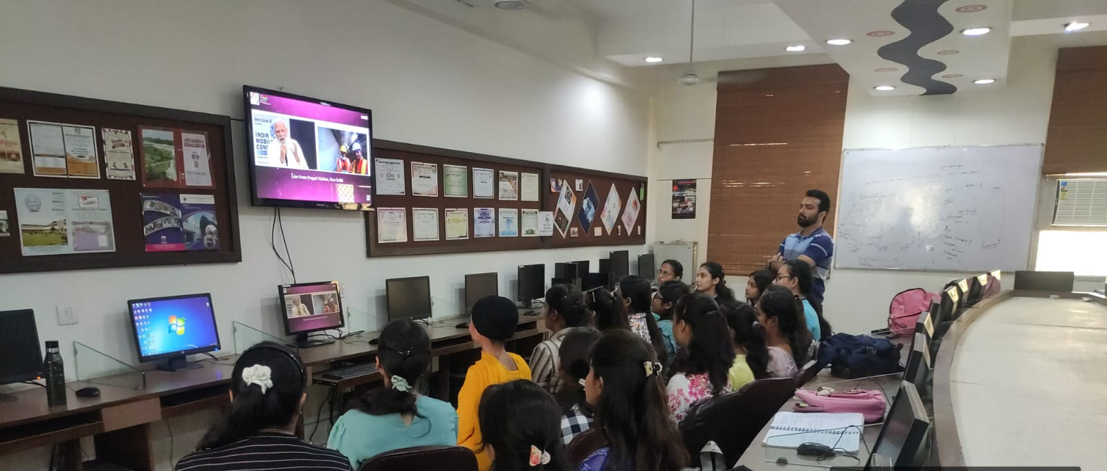
Ushering in a new technological era, the Prime Minister, Shri Narendra Modi launched 5G services in PragatiMaidan, New Delhi which was streamed online via YouTube platform. The stream was observed by the students of PG Department of Multimedia department where they were made aware about the new technology being inaugurated in 13 different cities. PM Modi gave a brief introduction about advantages a multimedia profession will have after the launch of 5G technology. The faculty of the department was also presented during the streaming. The stream was thoroughly very innovative.

March 18, 2023
Screening of Oscar Winning Documentary in HMV
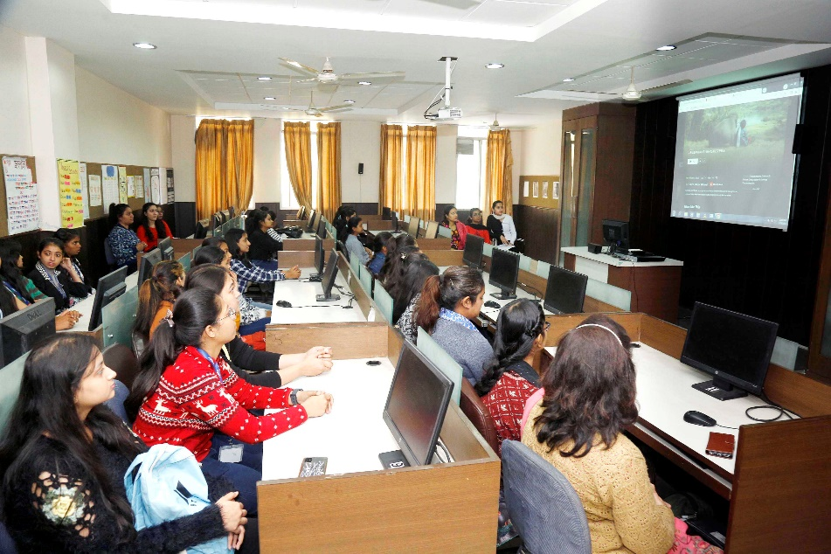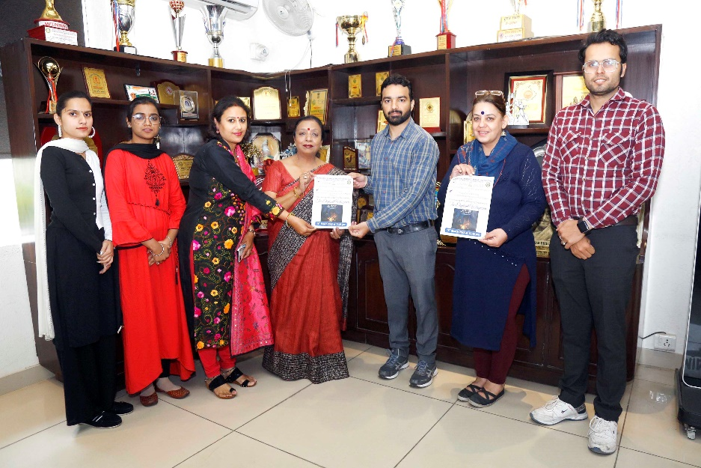
The PG Department of Mass Communication and Video Production and PG Department of Multimedia of Hans Raj MahilaMahaVidyalaya, Jalandhar jointly screened the Oscar Winning Documentary “The Elephant Whisperers” under the aegis of Institute Innovation Council. The students of Mass Communication, Multimedia and Botany Department watched the documentary. The students watched the documentary and discussed the various aspects of the documentary. Principal Prof. Dr. (Mrs.) Ajay Sareen appreciated the efforts of MCVP, Multimedia and IIC. She said that we all should feel proud of winning the Oscar. It is very important to tell different aspects of award winning documentary to the students and the special thing about the documentary. The students discussed various shots, editing techniques, the bond between man and animal shown in the documentary. All the students also wrote a review of documentary. On this occasion, Dr. Anjana Bhatia, Dean Research and Incharge IIC, Dr. Nitika, Mr. Ashish Chadha Head of Multimedia Department, Ms. Priyanka Jain, Ms. Priya Sharma, Mr. RishabhDhir were also present.
Guest Lectures on 3d Modeling in Blender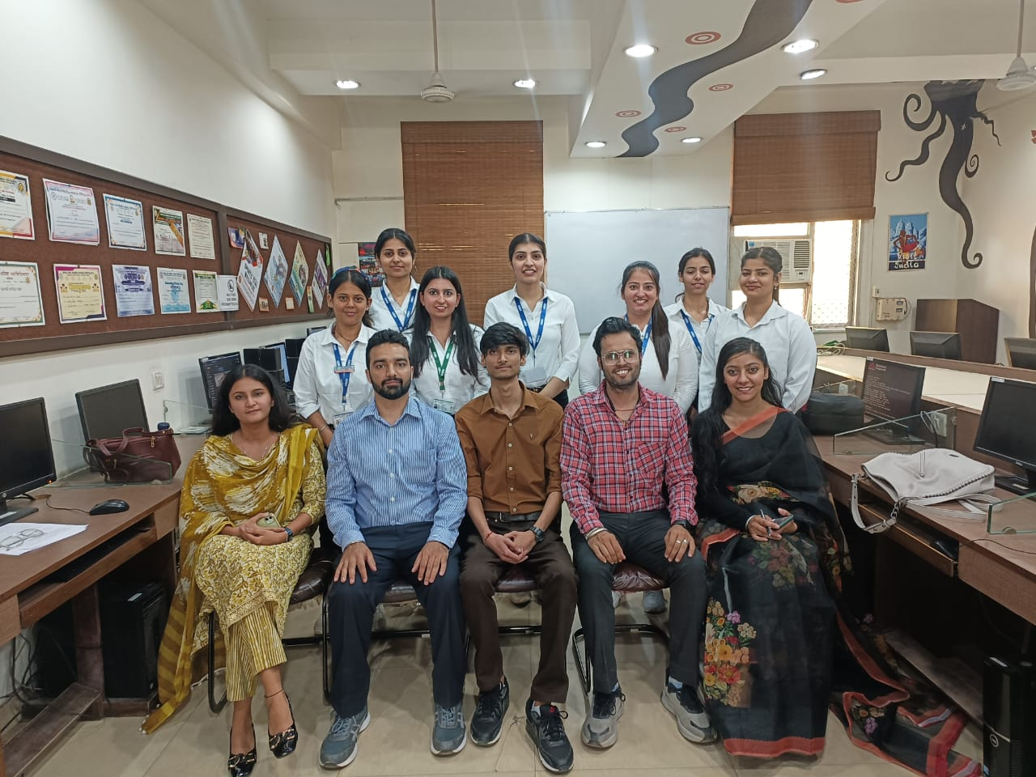
In a bid to enrich the academic experience for students, the PG Department of Multimedia at organized a captivating guest lecture on 3D Modeling in Blender. The esteemed speaker for the occasion was Mr. Utsav, a distinguished 3D artist with an impressive portfolio. The event, tailored for B.Design Multimedia Semester 6 students, provided invaluable insights into the latest trends and techniques in 3D modeling. Mr. Utsav's practical demonstrations and real-world examples left an indelible mark on the audience, inspiring them to explore new creative dimensions within the multimedia field. This event underscores its commitment to providing students with cutting-edge knowledge and exposure to industry professionals. The institution extends gratitude to Principal Prof. Dr. Mrs. Ajay Sareen for her unwavering support in facilitating such enriching initiatives.

